PROJECT REPORT

Electric Motor Temperature Prediction Using Machine Learning

1. INTRODUCTION
1.1 Project Overview
Electric Motor Temperature Prediction using Machine Learning is a predictive maintenance solution aimed at forecasting the temperature of electric motors in industrial settings. By analyzing historical operational data such as motor load, voltage, current, and environmental conditions, combined with machine learning algorithms, this project aims to predict motor temperatures accurately. The goal is to prevent overheating, avoid equipment failures, optimize maintenance schedules, and improve overall operational efficiency.
Electric motors are widely used in industrial environments for manufacturing and production processes. Continuous motor operation may lead to overheating, which can cause sudden failure, production downtime, and financial losses.
This project focuses on predicting the temperature of a Permanent Magnet Synchronous Motor (PMSM) using Machine Learning techniques. By analyzing parameters such as ambient temperature, coolant temperature, voltage, current, motor speed, and torque, the system predicts motor temperature in advance.
A Flask-based web application is developed to allow users to enter motor parameters and receive real-time temperature predictions.

1.2 Purpose
The purpose of this project is to develop a predictive maintenance system that forecasts motor temperature before overheating occurs using machine learning techniques. By analyzing historical motor operational data, the system identifies patterns and predicts temperature rise in advance, enabling timely preventive action.
This system helps industries to:
- Reduce unexpected equipment downtime
- Lower maintenance and repair costs
- Improve motor reliability and lifespan
- Enable data-driven preventive maintenance
- Enhance operational efficiency and productivity
By shifting from reactive maintenance to predictive maintenance, the project supports smarter decision-making and improved industrial performance.

2. IDEATION PHASE
2.1 Problem Statement
Industrial electric motors experience unexpected overheating, and there is no predictive system to forecast motor temperature in advance. This leads to sudden equipment failure, production downtime, and financial loss.

2.2 Empathy Map Canvas
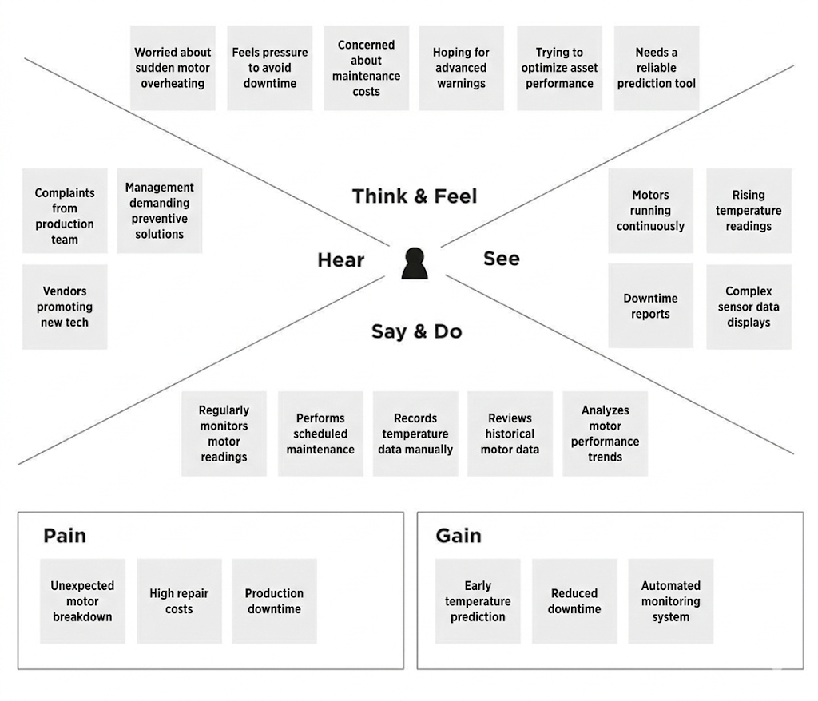

2.3 Brainstorming
During brainstorming, the following ideas were generated:
- ML-based temperature prediction
- Data preprocessing and feature scaling
- Model evaluation and comparison
- Flask web application deployment
- Saving model using pickle
After prioritization, Machine Learning-based temperature prediction with web deployment was selected.

3. REQUIREMENT ANALYSIS
3.1 Customer Journey Map
- Engineer monitors motor parameters.
- Data is analyzed using ML model.
- System predicts temperature.
- Engineer takes preventive action.
- Downtime is minimized.

3.2 Solution Requirements
The proposed solution aims to develop a machine learning-based predictive system for forecasting electric motor temperature. The system must meet the following requirements:
Functional Requirements
- The system should accept motor input parameters such as ambient temperature, coolant temperature, voltage, current, motor speed, and torque.
- The system should preprocess the input data appropriately before prediction.
- The trained machine learning model should predict the motor temperature accurately.
- The predicted temperature should be displayed clearly on the web interface.
- The model should be saved and loaded for real-time inference using Flask.

Non-Functional Requirements
- The system should provide accurate and reliable predictions.
- The response time should be fast for real-time usage.
- The web interface should be simple and user-friendly.
- The system should be scalable for future integration with IoT or cloud platforms.
- The solution should be maintainable and allow periodic model retraining if required.

3.3 Data Flow Diagram / Technical Architecture
The project follows the below workflow:
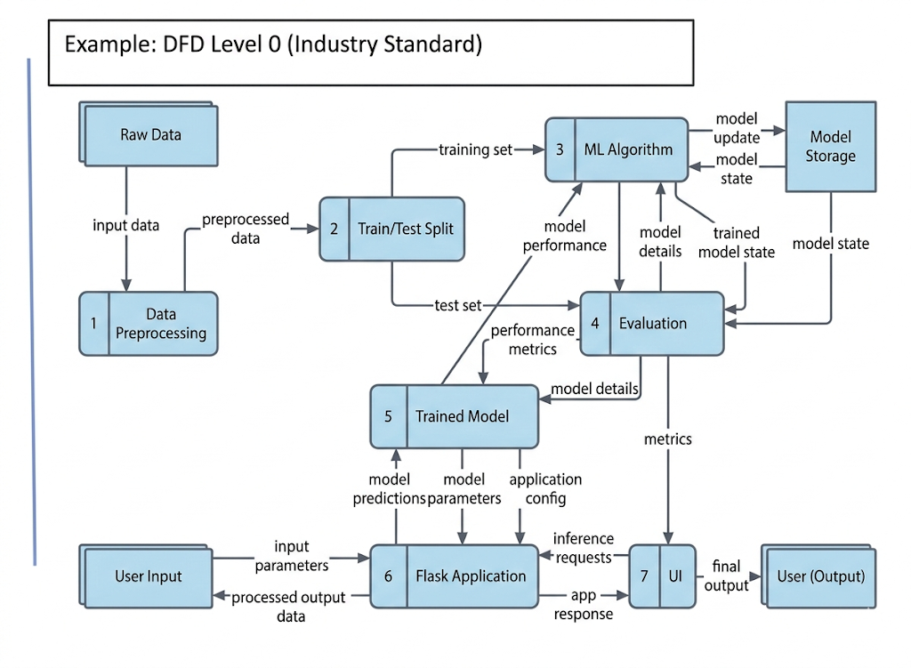
Project Flow Explanation
- The user interacts with the web interface and enters motor parameter values.
- The input is sent to the Flask backend.
- The integrated trained ML model analyzes the input.
- The model predicts the motor temperature.
- The predicted result is displayed on the UI.
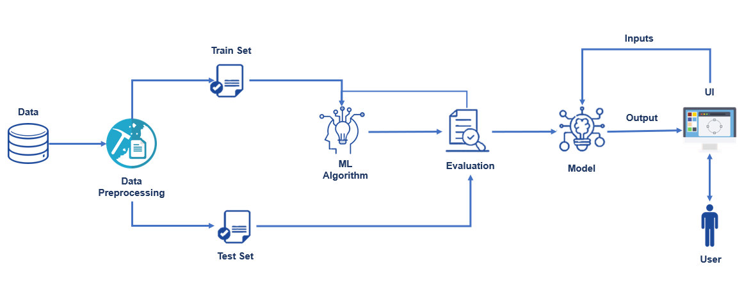

3.4 Technology Stack
The project utilizes the following technologies and tools for data analysis, model development, and application deployment:
Programming Language
- Python – Used for data processing, machine learning model development, and backend integration.
Data Handling & Analysis
- Pandas – For loading, cleaning, and manipulating the dataset.
- NumPy – For numerical computations and array operations.
Data Visualization
- Matplotlib – For plotting graphs and visual analysis.
- Seaborn – For advanced statistical visualizations such as correlation heatmaps.
Machine Learning
- Scikit-learn – For model training, testing, evaluation, and performance metrics.
- Pickle – For saving and loading the trained machine learning model.
Web Application Development
- Flask – Lightweight web framework used to integrate the trained model and handle user input/output.
- HTML/CSS – For designing the user interface.
Development Environment
- Google Colab – Used for Exploratory Data Analysis and model training.
- VS Code – Used for developing the Flask application.

4. PROJECT DESIGN
4.1 Problem-Solution Fit
Industrial electric motors are critical components in manufacturing and production environments. One of the major challenges faced by industries is unexpected motor overheating, which can result in sudden equipment failure, production downtime, and increased maintenance costs. Traditional monitoring systems only display current temperature readings and do not provide predictive insights, making it difficult to take preventive action in advance.
The proposed solution addresses this gap by implementing a Machine Learning-based predictive maintenance system. By analyzing historical motor operational data such as ambient temperature, coolant temperature, voltage, current, motor speed, and torque, the system learns patterns associated with temperature variation. The trained regression model can then predict motor temperature before critical overheating occurs.
This solution effectively fits the identified problem because:
- It shifts maintenance strategy from reactive to predictive.
- It provides early warning of potential overheating.
- It reduces downtime and maintenance costs.
- It enables data-driven decision-making for industrial operations.
Thus, the machine learning model combined with a Flask-based web application provides a practical, scalable, and efficient solution to the problem of unexpected motor overheating.

4.2 Proposed Solution
The proposed solution is a Machine Learning-based predictive maintenance system designed to forecast the temperature of a Permanent Magnet Synchronous Motor (PMSM) using historical operational data.
The solution involves the following components:
- Data Analysis and Preprocessing:
The PMSM dataset is analyzed using exploratory data analysis techniques to understand feature relationships. Necessary preprocessing steps such as handling missing values, feature scaling, and train-test splitting are performed to prepare the data for model training.
- Model Development:
A regression-based Machine Learning model is trained using relevant motor parameters such as ambient temperature, coolant temperature, voltage, current, motor speed, and torque. The model learns patterns between input features and motor temperature.
- Model Evaluation:
The trained model is evaluated using performance metrics such as R² Score, Mean Absolute Error (MAE), and Mean Squared Error (MSE) to ensure accuracy and reliability.
- Model Deployment:
The final trained model is saved using pickle and integrated into a Flask-based web application.
- User Interaction:
The web interface allows users to input motor parameters, and the system instantly predicts and displays the motor temperature.
This solution provides a practical and scalable approach for predictive maintenance. By forecasting motor temperature in advance, industries can take preventive actions to reduce equipment failure, minimize downtime, and improve operational efficiency.

4.3 Solution Architecture
The solution architecture of the Electric Motor Temperature Prediction system is designed to ensure smooth data processing, accurate prediction, and real-time user interaction.
The architecture consists of the following components:
- Data Layer
The PMSM dataset contains motor operational parameters such as ambient temperature, coolant temperature, voltage, current, motor speed, and torque. This data is used for training and testing the machine learning model.
- Data Processing Layer
The dataset undergoes preprocessing steps including:
- Checking for null values
- Feature selection
- Feature scaling
- Splitting into training and testing sets
This ensures that the data is clean and suitable for model training.
- Machine Learning Layer
A regression-based machine learning model is trained using the processed data.
The model learns the relationship between input parameters and motor temperature.
After training and evaluation, the model is saved using pickle for deployment.
- Application Layer (Flask Backend)
The trained model is integrated into a Flask web application.
When a user enters motor parameters, the Flask backend:
- Receives the input
- Applies necessary preprocessing
- Sends the data to the trained model
- Retrieves the predicted temperature
- Presentation Layer (User Interface)
The HTML-based web interface allows users to:
- Enter motor parameters
- Submit the form
- View the predicted motor temperature instantly

🔹 Overall Workflow
User → HTML Form → Flask Backend → Trained ML Model → Prediction → Display Output
This layered architecture ensures modularity, scalability, and efficient prediction performance while maintaining a simple and user-friendly interface.

5. PROJECT PLANNING & SCHEDULING
5.1 Project Planning
The project was planned and executed in a structured manner to ensure systematic development, testing, and deployment of the machine learning-based temperature prediction system.
The development was divided into the following phases:
Phase 1: Problem Understanding & Dataset Collection
- Identified the problem of motor overheating in industrial environments.
- Collected and loaded the PMSM temperature dataset.
- Understood features and target variable.
Phase 2: Exploratory Data Analysis (EDA)
- Performed descriptive statistical analysis.
- Conducted univariate and multivariate analysis.
- Generated correlation heatmaps to identify feature relationships.
Phase 3: Data Preprocessing
- Checked for missing values.
- Selected relevant features.
- Applied feature scaling.
- Split dataset into training and testing sets.
Phase 4: Model Development
- Imported machine learning libraries.
- Initialized regression model.
- Trained and tested the model.
- Evaluated performance using R², MAE, and MSE.
- Saved trained model using pickle.
Phase 5: Application Development
- Designed HTML user interface.
- Developed Flask backend.
- Integrated trained model into Flask application.
- Tested real-time prediction functionality.
Phase 6: Testing & Documentation
- Verified prediction accuracy.
- Tested user interface responsiveness.
- Prepared project documentation and report.

6. FUNCTIONAL AND PERFORMANCE TESTING
6.1 Performance Testing
To evaluate the performance of different regression models, multiple algorithms were trained and tested on the PMSM dataset. The models compared include Linear Regression, Decision Tree, and Random Forest.
🔹 Model Comparison Results
Linear Regression
- R² Score: 0.6028
Decision Tree
- R² Score: 0.8820
- RMSE: 6.5276
Random Forest
- R² Score: 0.9357
- RMSE: 4.8207
- Training R² Score: 0.9375
- Testing R² Score: 0.9357
🔹 Analysis of Results
Among all models, the Random Forest Regressor achieved the highest performance:
- The R² score of 0.9357 indicates that the model explains approximately 93.56% of the variance in motor temperature.
- The RMSE value of 4.8207 shows that the prediction error is low and stable.
- The training R² (0.9375) and testing R² (0.9357) are very close, which indicates that the model is well-generalized and not overfitting.
Compared to Linear Regression (R² = 0.6028) and Decision Tree (R² = 0.8820), the Random Forest model performed significantly better.
🔹 Final Model Selection
Based on accuracy and stability, the Random Forest model was selected as the final model.
The trained model was saved using pickle and integrated into the Flask web application for real-time temperature prediction.
7. RESULTS
The developed machine learning models were evaluated using the PMSM dataset to predict motor temperature. Multiple regression algorithms were tested, and their performance was compared. Based on evaluation metrics, the Random Forest model achieved the highest accuracy and was selected as the final model.
The trained model was then integrated into a Flask web application to provide real-time temperature prediction. The following screenshots demonstrate dataset analysis, model evaluation, and application deployment results.
7.1 Output Screenshots
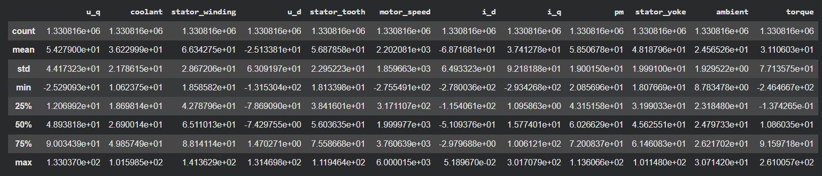
Figure 7.1: PMSM dataset loaded and initial exploratory data analysis in Google Colab.
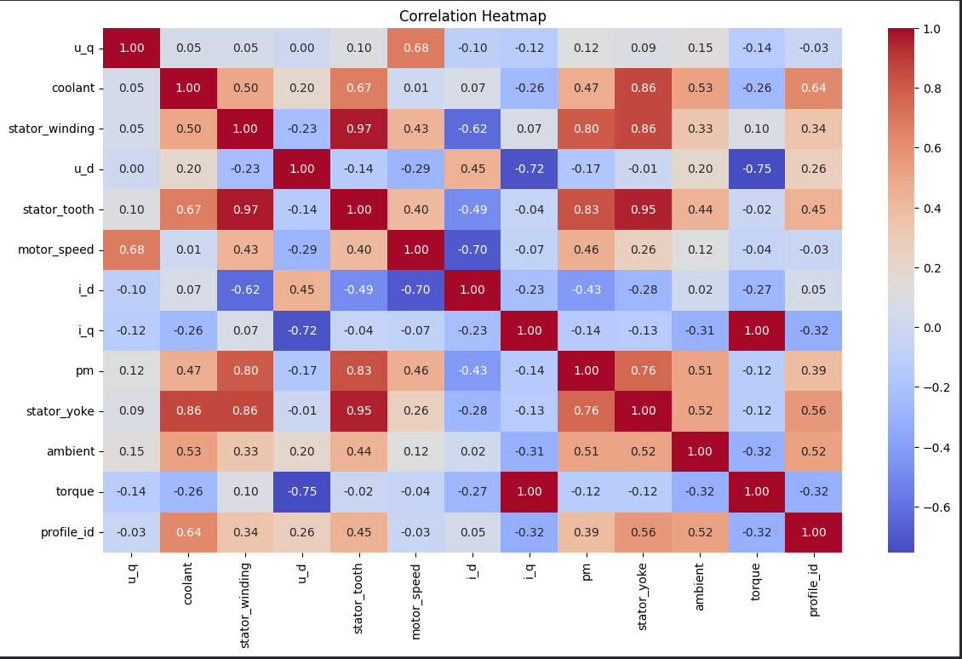
Figure 7.2: Correlation heatmap showing relationship between motor parameters and target temperature.

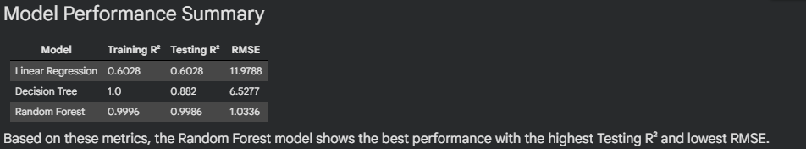
Figure 7.3: Performance comparison of Linear Regression, Decision Tree, and Random Forest models.
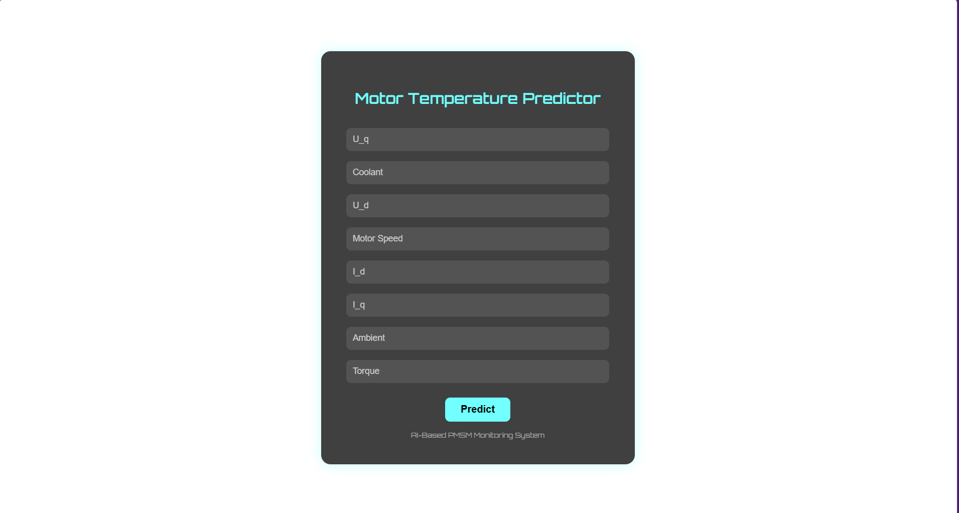
Figure 7.4: Flask web application interface for entering motor parameters.

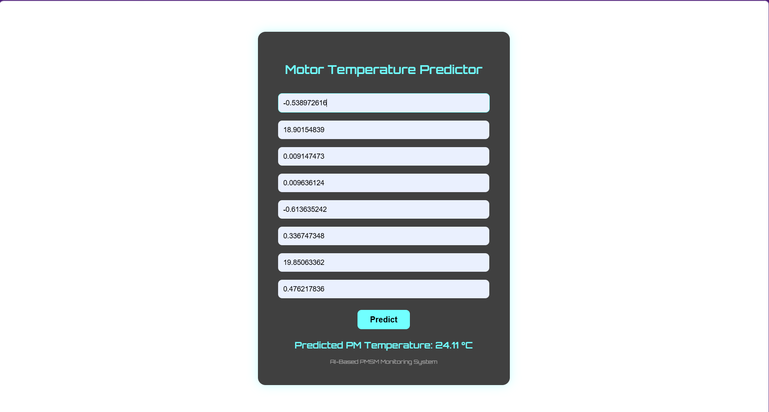
Figure 7.5: Predicted motor temperature displayed on the web interface.
The results demonstrate that the Random Forest regression model provides accurate and reliable motor temperature predictions and successfully integrates with the web application for real-time usage.

8. ADVANTAGES & DISADVANTAGES
Advantages
- Early Detection of Overheating:
The system predicts motor temperature in advance, enabling preventive action before critical overheating occurs.
- Reduced Production Downtime:
By forecasting potential temperature rise, industries can avoid sudden motor failures and unexpected shutdowns.
- Lower Maintenance Costs:
Predictive maintenance reduces emergency repairs and extends motor lifespan, lowering overall maintenance expenses.
- Improved Decision-Making:
The model provides data-driven insights, helping engineers take informed maintenance decisions.
- Simple and User-Friendly Interface:
The Flask-based web application allows easy input of motor parameters and instant prediction results.

Disadvantages
- Dependent on Dataset Quality:
The accuracy of predictions depends on the quality and completeness of the training dataset.
- Not Integrated with Real-Time IoT Sensors:
The current system uses static input values and is not connected to live sensor data.
- Requires Periodic Retraining:
The model may need retraining when new motor data becomes available to maintain accuracy.
- Limited to PMSM Dataset Scope:
The model is trained specifically on PMSM motor data and may require modification for other motor types.

9. CONCLUSION
The Electric Motor Temperature Prediction system successfully demonstrates the application of Machine Learning in predictive maintenance for industrial environments. By analyzing operational parameters such as ambient temperature, coolant temperature, voltage, current, motor speed, and torque, the developed regression model accurately predicts the temperature of a Permanent Magnet Synchronous Motor (PMSM).
Among the tested models, the Random Forest Regressor achieved the highest performance with an R² score of 0.9357, indicating strong predictive capability and good generalization between training and testing data. This confirms that the model can reliably forecast motor temperature with minimal error.
The trained model was successfully integrated into a Flask-based web application, enabling real-time temperature prediction through a simple and user-friendly interface. This implementation demonstrates how machine learning models can be deployed in practical industrial scenarios.
Overall, the project highlights the effectiveness of predictive analytics in reducing equipment downtime, lowering maintenance costs, and improving operational efficiency. The system provides a scalable foundation for future enhancements such as real-time IoT integration and cloud deployment.

10. FUTURE SCOPE
- Integration with real-time IoT sensors for continuous data acquisition and live temperature prediction.
- Deployment on cloud infrastructure (AWS/Azure) for scalable, remote industrial monitoring.
- Implementation of advanced deep learning models such as ANN or LSTM to enhance prediction accuracy.
- Development of an interactive analytics dashboard for visualizing temperature trends and performance metrics.
- Incorporation of automated alert mechanisms (Email/SMS notifications) for threshold-based warnings.
- Extension of the system to support multi-motor monitoring in large-scale industrial environments.

11. APPENDIX
Appendix A – Source Code
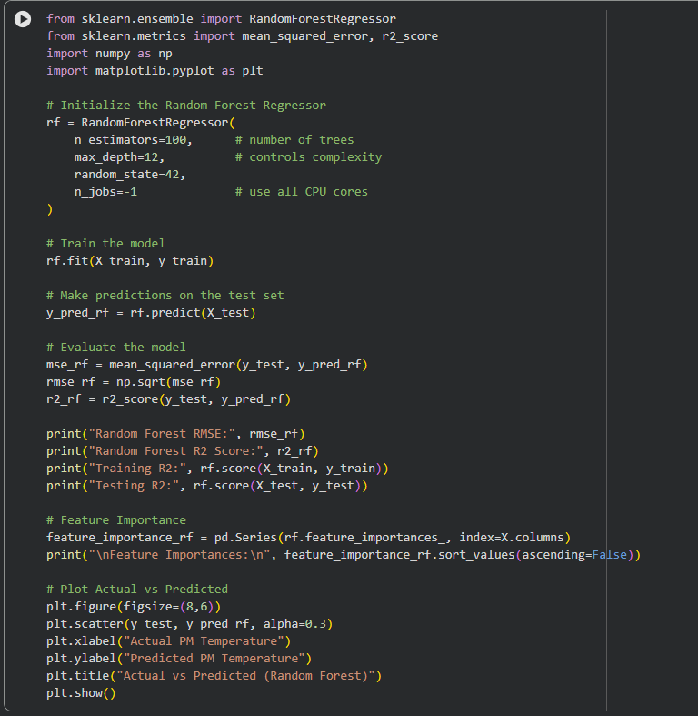
Appendix B – Dataset Information
Dataset Name: PMSM Temperature Dataset
Number of records: 1,330,816
Number of features: 8 (after preprocessing)
Target Variable: pm (Permanent Magnet Temperature)
Dataset Link:https://www.kaggle.com/datasets/wkirgsn/electric-motor-temperature

Appendix C – GitHub Repository
https://github.com/Arshia137/Electric-Motor-Temperature-Prediction-using-Machine-Learning.git

